Day 20 - 25th July- 113195064 - Bondili Bhavya Charitha

TASK: 3
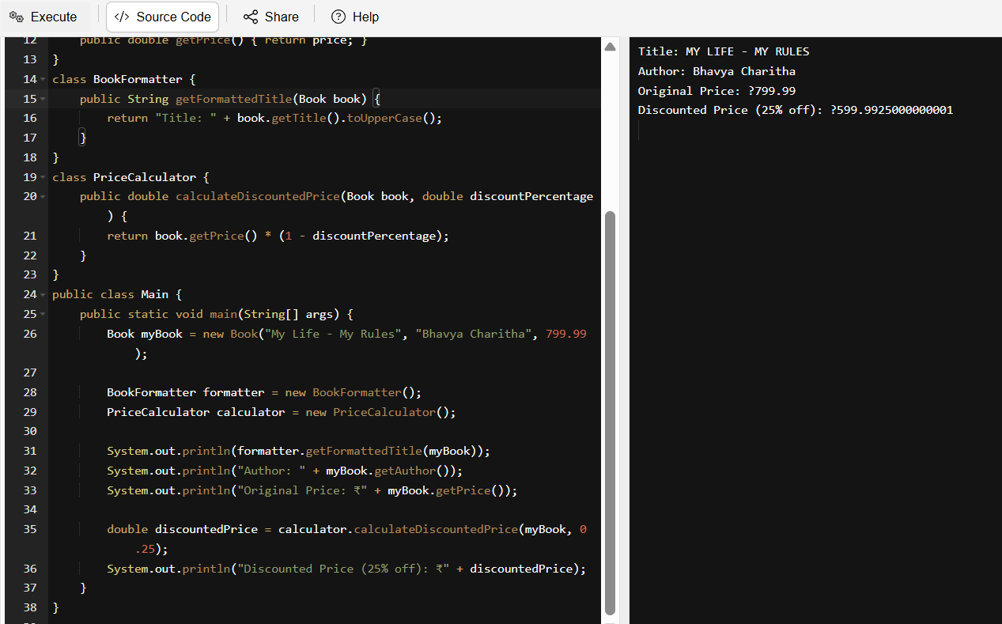
class Book {
private String title;
private String author;
private double price;
public Book(String title, String author, double price) {
this.title = title;
this.author = author;
this.price = price;
}
public String getTitle() { return title; }
public String getAuthor() { return author; }
public double getPrice() { return price; }
}
class BookFormatter {
public String getFormattedTitle(Book book) {
return "Title: " + book.getTitle().toUpperCase();
}
}
class PriceCalculator {
public double calculateDiscountedPrice(Book book, double discountPercentage) {
return book.getPrice() * (1 - discountPercentage);
}
}
public class Main {
public static void main(String[] args) {
Book myBook = new Book("My Life - My Rules", "Bhavya Charitha", 799.99);

BookFormatter formatter = new BookFormatter();
PriceCalculator calculator = new PriceCalculator();

System.out.println(formatter.getFormattedTitle(myBook));
System.out.println("Author: " + myBook.getAuthor());
System.out.println("Original Price: ₹" + myBook.getPrice());

double discountedPrice = calculator.calculateDiscountedPrice(myBook, 0.25);
System.out.println("Discounted Price (25% off): ₹" + discountedPrice);
}
}

TASK:4 –
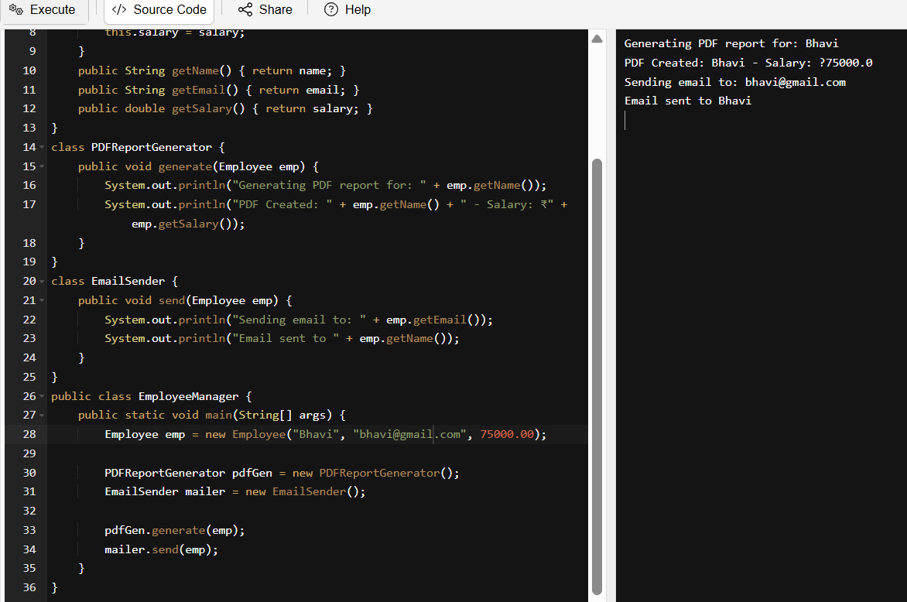
class Employee {
private String name;
private String email;
private double salary;
public Employee(String name, String email, double salary) {
this.name = name;
this.email = email;
this.salary = salary;
}
public String getName() { return name; }
public String getEmail() { return email; }
public double getSalary() { return salary; }
}
class PDFReportGenerator {
public void generate(Employee emp) {
System.out.println("Generating PDF report for: " + emp.getName());
System.out.println("PDF Created: " + emp.getName() + " - Salary: ₹" + emp.getSalary());
}
}
class EmailSender {
public void send(Employee emp) {
System.out.println("Sending email to: " + emp.getEmail());
System.out.println("Email sent to " + emp.getName());
}
}
public class EmployeeManager {
public static void main(String[] args) {
Employee emp = new Employee("Bhavi", "bhavi@gmail.com", 75000.00);

PDFReportGenerator pdfGen = new PDFReportGenerator();
EmailSender mailer = new EmailSender();

pdfGen.generate(emp);
mailer.send(emp);
}
}
TASK:5
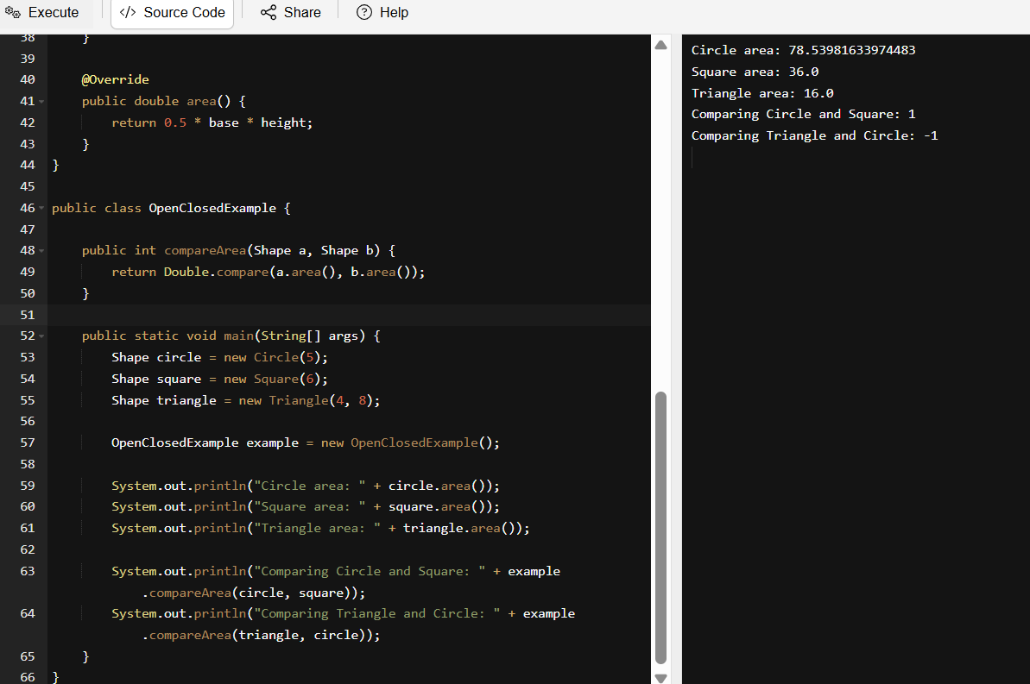
interface Shape {
double area();
}
class Circle implements Shape {
private int radius;

public Circle(int radius) {
this.radius = radius;
}

@Override
public double area() {
return Math.PI * radius * radius;
}
}

class Square implements Shape {
private int height;

public Square(int height) {
this.height = height;
}

@Override
public double area() {
return height * height;
}
}

class Triangle implements Shape {
private int base;
private int height;

public Triangle(int base, int height) {
this.base = base;
this.height = height;
}

@Override
public double area() {
return 0.5 * base * height;
}
}

public class OpenClosedExample {

public int compareArea(Shape a, Shape b) {
return Double.compare(a.area(), b.area());
}

public static void main(String[] args) {
Shape circle = new Circle(5);
Shape square = new Square(6);
Shape triangle = new Triangle(4, 8);

OpenClosedExample example = new OpenClosedExample();

System.out.println("Circle area: " + circle.area());
System.out.println("Square area: " + square.area());
System.out.println("Triangle area: " + triangle.area());

System.out.println("Comparing Circle and Square: " + example.compareArea(circle, square));
System.out.println("Comparing Triangle and Circle: " + example.compareArea(triangle, circle));
}
}

TASK: 6
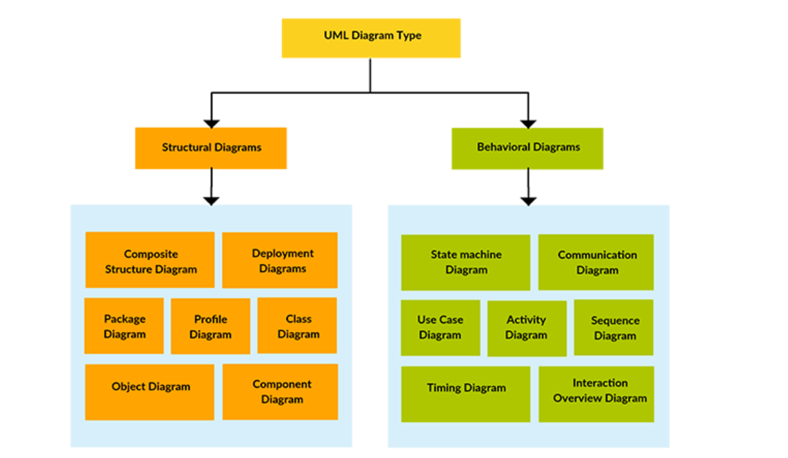

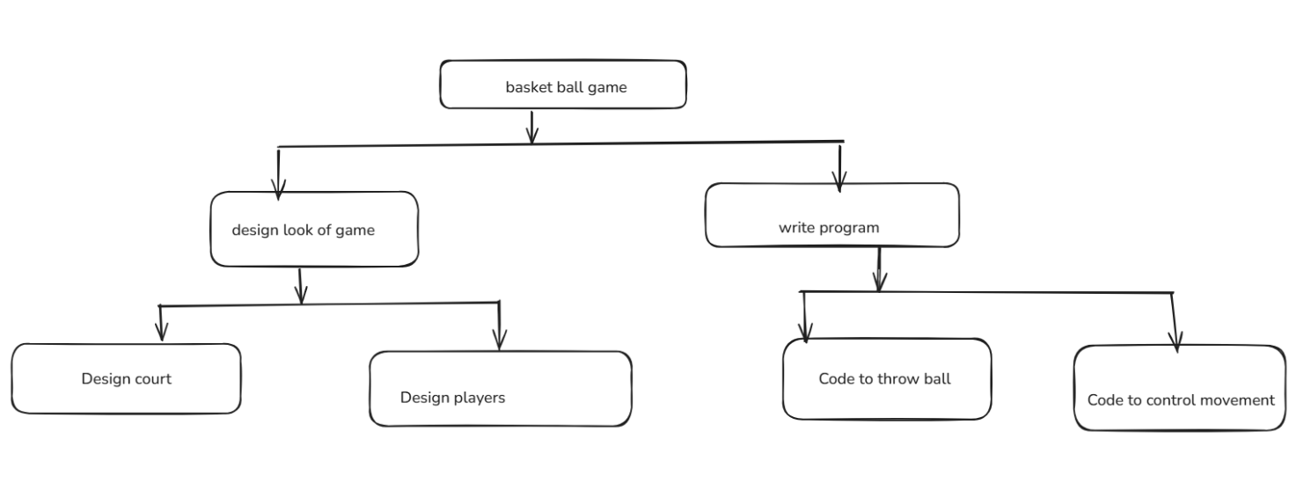

Home Tasks:
Doc 6 - Exercises on uml basics.pdf – Done ✅
TASK: 1 - Wap to create a class Student. With 3 methods registrationDetails(), marksCalc(), feesCalc().
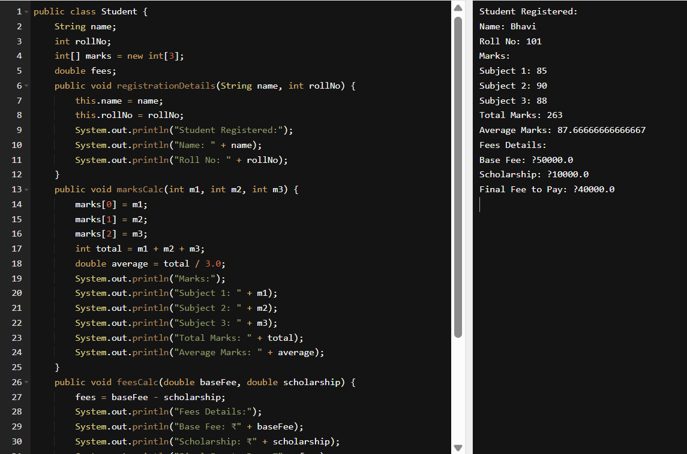
public class Student {
String name;
int rollNo;
int[] marks = new int[3];
double fees;
public void registrationDetails(String name, int rollNo) {
this.name = name;
this.rollNo = rollNo;
System.out.println("Student Registered:");
System.out.println("Name: " + name);
System.out.println("Roll No: " + rollNo);
}
public void marksCalc(int m1, int m2, int m3) {
marks[0] = m1;
marks[1] = m2;
marks[2] = m3;
int total = m1 + m2 + m3;
double average = total / 3.0;
System.out.println("Marks:");
System.out.println("Subject 1: " + m1);
System.out.println("Subject 2: " + m2);
System.out.println("Subject 3: " + m3);
System.out.println("Total Marks: " + total);
System.out.println("Average Marks: " + average);
}
public void feesCalc(double baseFee, double scholarship) {
fees = baseFee - scholarship;
System.out.println("Fees Details:");
System.out.println("Base Fee: ₹" + baseFee);
System.out.println("Scholarship: ₹" + scholarship);
System.out.println("Final Fee to Pay: ₹" + fees);
}
public static void main(String[] args) {
Student s1 = new Student();
s1.registrationDetails("Bhavi", 101);
s1.marksCalc(85, 90, 88);
s1.feesCalc(50000, 10000);
}
}

